01 / THE DECISION / EXECUTIVE BRIEF

The next
100,000 m³.
What would it take to supply a small coastal city with more freshwater, and when does seawater desalination make more sense than reuse or conservation?
WORKING ANSWER · CONDITIONAL SYNTHESIS
Test conservation and eligible reuse first. Develop desalination for the dependable gap that remains, when marine feasibility, power and delivered cost support it. A large seawater plant is justified by a persistent residual need, not by the size of the ocean. [S01] [S03]
36.5 million 111,111 138.7 GWh
m³/year of additional service m³/day nameplate at 90% use annual full-target SWRO electricity
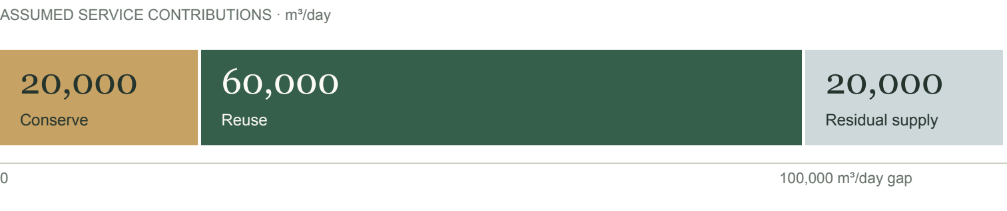
Exhibit A · An illustrative portfolio: 20,000 m³/day saved + 60,000 reused + 20,000 residual supply. Values are assumptions and calculations, not an optimized project.
The case is Port Meridian, a fictional city of 300,000 residents with port, tourism and industrial demand. The target is an annual-average service gap. If seawater alone supplies it, our transparent screen gives about $1.44/m³ and $52.39 million/year in assumed 2026 USD. The reuse comparator is cheaper but cannot cover the full gap with the assumed wastewater supply.
THE DECISIVE UNKNOWN
How much demand can be reduced permanently, and how much eligible dry-weather effluent remains afterward? Those two measurements could remove the need for desalination or make a larger plant necessary.

02 / DEFINE THE PROBLEM

First, specify the
water you need.
An average annual volume, a peak-day requirement and an outage-proof supply are three different obligations. This dossier calculates only the first.
Illustrative city input | Assumption
Residents | 300,000; plus port, tourism and industry
Current system demand | 200,000 m³/day, all sectors
Existing dry-year supply | 100,000 m³/day annual average
Additional service gap | 100,000 m³/day = 36.5 million m³/year
New-water delivery boundary | Utility interface; common downstream distribution excluded

These are constructed planning assumptions, not measurements of a real utility. The additional target alone equals 333 liters per resident per day. That is a substantial increment for this population: confirm the demand boundary, industrial needs and drought losses before choosing any project.
CAPACITY IS NOT ANNUAL YIELD
Required nameplate = 100,000 ÷ 0.90 = 111,111 m³/day
A 100,000 m³/day plant at 90% utilization supplies only 32.85 million m³/year, leaving 3.65 million m³/year uncovered. Our calculator instead holds delivered volume fixed and increases installed capacity as utilization falls. Its simple linear capital scaling is an assumption.

An outage still needs another source
Annual arithmetic does not establish dependable daily delivery. A complete three-day outage requires 300,000 m³ of stored or alternate water at this full target, before safety margins. Redundant trains can help with equipment outages; a shared intake or grid failure can affect all trains. Seawater quality events also matter. [S03]
BOUNDARY DISCIPLINE
Reuse begins with eligible secondary-treated effluent. Conservation is a reduction in demand, not newly produced water. Both must be assessed after existing commitments and any effects on each other; gross savings and lost reuse feed cannot be counted twice.

03 / COMPARE THE OPTIONS

Three options,
three different limits.
The useful comparison is cost per dependable unit of service within a common boundary, together with the volume each option can actually provide.
Option | Case contribution | Binding question
Conservation | 20,000 m³/day saved | Are additional savings real and durable?
Advanced reuse | 60,000 m³/day delivered | Is eligible effluent available in the dry year?
Seawater RO | 20,000 m³/day residual to investigate | Can the coast, power supply and budget support it?

Conservation: verify the remaining opportunity
California reported a 22.5% cumulative urban-use reduction during June 2015-December 2016 relative to 2013. That shows substantial demand change is possible; it does not prove this city's remaining potential or permanent savings. EPA stresses site-specific opportunity. An assumed $3.65 million/year program saving 20,000 m³/day costs $0.50/m³ saved, rising to $1.00 if sustained yield halves. [S06] [S03]

Reuse: count the feed before buying the capacity
Assume 75,000 m³/day of eligible effluent after conservation and existing obligations, with 80% net recovery: 60,000 m³/day reaches the utility. OCWD's 130-MGD system demonstrates municipal scale, but its source control, treatment, recharge system and public acceptance are part of the result. An available treatment process does not establish an available local water source. [S04]

Desalination: fill a persistent residual
Seawater can support a source less exposed to rainfall when conservation is exhausted and reuse feed is limited. It brings electricity demand, intake and discharge infrastructure, post-treatment, delivery and specialist operations. Non-potable reuse can also displace potable demand where nearby customers and suitable networks exist. [S02] [S03]
WHAT WOULD CHANGE THE SPLIT?
At 80% net recovery, 100,000 m³/day of eligible post-conservation effluent would supply the remaining 80,000 m³/day. Savings plus reuse could then close the gap. If only 37,500 m³/day is eligible, the residual rises to 50,000 m³/day.

04 / THE PHYSICAL SYSTEM

What a seawater
option requires.
For the full 100,000 m³/day annual-average target, the system is an intake, a treatment works, an energy connection and a delivery network.
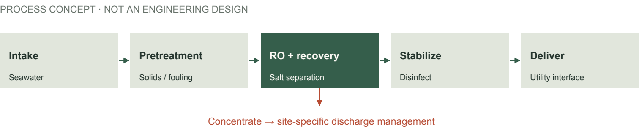
Exhibit B · Conceptual process only. Pretreatment protects the membrane; energy recovery reduces pumping load; stabilization and disinfection prepare water for delivery. [S02]
Simplified flow | Annual-average day | While online at 90%
Freshwater product | 100,000 m³/day | 111,111 m³/day
Seawater feed, 45% recovery | 222,222 m³/day | 246,914 m³/day
Concentrate before dilution | 122,222 m³/day | 135,802 m³/day

At an assumed 35 g/L feed salinity and 45% recovery, the simplified concentrate is about 63.6 g/L before dilution. This neglects product salt, density differences, pretreatment losses and dilution water. It is a mass balance, not an environmental impact prediction.
ELECTRICITY AT THE DELIVERY BOUNDARY
36.5 million m³/year × 3.8 kWh/m³ = 138.7 GWh/year
The 3.8-kWh/m³ assumption comprises 3.5 for the plant and 0.3 for delivery. That means 15.83 MW averaged over the year, or about 17.59 MW during operation at 90% utilization. DOE's 3.3-kWh/m³ reference is the RO separation step alone; intake, other treatment and delivery must not disappear from the accounting. [S02] [S10]
SITE WORK STILL TO DEFINE
Land and access, marine works, source-water pretreatment, water-quality stabilization, residuals handling, grid reinforcement, delivery alignment and outage cover are unmeasured. A 100 m lift at 80% pump efficiency alone adds about 0.341 kWh/m³ before friction. No footprint or construction schedule is claimed.

05 / COST / READ THE BOUNDARY

A price is only useful
when its scope is clear.
The screen annualizes assumed capital and operations in real 2026 USD. It is a consistent comparison device, not a tariff or an engineering estimate.
At 90% use; $0.12/kWh | Full-target SWRO | Full-target reuse*
Installed capital, assumed | $388.9 million | $222.2 million
Annualized capital, per m³ | $0.616 | $0.352
Fixed O&M, per m³ | $0.213 | $0.122
Non-energy variable O&M | $0.150/m³ | $0.150/m³
Electricity, per m³ | $0.456 | $0.120
Total cost, rounded | $1.44/m³ | $0.74/m³
Annual total | $52.39 million | $27.15 million

* AVAILABILITY LIMIT
Reuse is an equal-volume financial comparator here. It cannot supply 100,000 m³/day under this case's 60,000 m³/day reuse-yield assumption. The 20/60/20 portfolio has not been independently costed; small-plant scaling and shared infrastructure could alter it.
At the default power price and utilization, jointly varying assumed capital, intensity and variable costs gives stress ranges of $1.05-$2.32/m³ for SWRO and $0.54-$1.44/m³ for reuse. These are chosen scenarios, not confidence intervals or published project quotes. Inputs and exclusions are on page 9.

Keep historical examples in their own frame
World Bank's historical SWRO database reports $0.49-$2.86/m³ in 2016 USD; some entries are modeled and others reflect special financing or delivery conditions. EPA's 2017 reuse compendium cites a $0.7-$1.6/m³ range from earlier research, including costly conveyance and brine disposal in high-end cases. Different vintages and boundaries prevent a clean price ranking. [S01] [S03]
Carlsbad's 2015 $1 billion disclosure includes its plant, 10-mile pipeline and distribution upgrades. OCWD's $284 million figure is a 2023 expansion on an existing reuse system. Santa Barbara's $72 million was reactivation capital. These explain scope differences; none is a plug-in estimate for Port Meridian. [S05] [S04] [S08]

06 / ENERGY / CARBON SENSITIVITY

The power supply
changes the carbon case.
Full-target SWRO uses 138.7 GWh/year in this model. The equal-volume reuse comparator uses 36.5 GWh/year. These are incremental treatment-and-delivery loads.
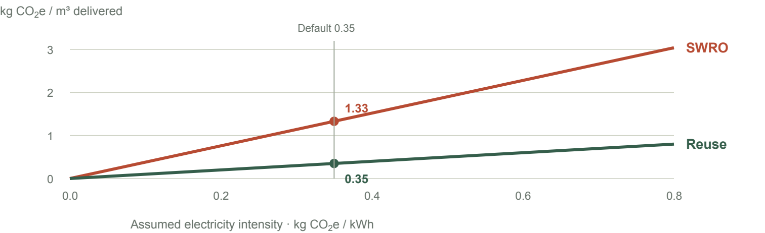
Exhibit C · Electricity-use emissions vary linearly with the assumed grid factor. No embodied materials, chemicals, direct process emissions or marginal-grid effects are included. [S11]
Assumed kg CO₂e/kWh | SWRO t CO₂e/year | Reuse t CO₂e/year
0.05 | 6,935 | 1,825
0.35 · default | 48,545 | 12,775
0.70 | 97,090 | 25,550

To stay below an illustrative 0.5 kg CO₂e/m³ electricity-emissions ceiling, SWRO needs a factor below roughly 0.132 kg CO₂e/kWh. This is not a regulation. Annual averages or renewable contracts do not establish emissions during the hours of added load.

The economics are sensitive, too
A $0.10/kWh rise adds $0.38/m³ ($13.87 million/year) to full-target SWRO, versus $0.10/m³ for reuse. Lower utilization in the reader increases capacity and fixed cost; annual output and electricity stay constant.
THE COUNTERCASE
Reuse intensity depends on the treatment train. The research case uses 0.84 kWh/m³ for RO-based reuse; EPA describes a complex planned train projected near 3.0 kWh/m³. Added barriers, salinity or pumping can narrow the gap. [S09] [S03]

07 / ENVIRONMENT / DISPUTED EVIDENCE

A feasible coast
is not a given.
A large water source does not imply an acceptable intake or outfall. Marine effects and the local approval pathway need their own evidence.

Intake and discharge are separate questions
Intakes can affect organisms drawn toward or into the system. Dense concentrate can expose seabed organisms to elevated salinity. California's framework examines siting, design and mitigation; its scientific brine panel emphasizes mixing, monitoring and local exposure. Those are useful categories of inquiry, not a finding that a Port Meridian site can be approved. [S07] [S13]
Subsurface intakes may reduce biological impacts, but yield and construction depend on local geology and hydrogeology. Outfalls need bathymetry, currents, habitats, discharge composition and appropriate plume studies. A diffuser or a low-carbon electricity contract does not settle these questions.
READ THE REPORT WITH ITS RESPONSE
2024 · Expert panel The subsurface-intake panel proposes a staged feasibility framework and discusses cost, scale and implementation challenges.
2025 · Regulator memo The attached response calls it a high-level guide, challenges support for some generalizations and warns against confusing proposed procedures with current requirements.
The defensible conclusion is to obtain site-specific evidence and applicable guidance. It is not to declare all subsurface intakes feasible, or to dismiss them as too expensive. The disagreement is about the adequacy and interpretation of guidance; it does not resolve the fictional site's conditions. [S12]
A PORTFOLIO INTERACTION TO CHECK
If treated effluent is reused, less may remain for a colocated brine-dilution stream. That is an inference from the co-discharge mass balance, not a measured local problem. Reuse also creates concentrate or other residuals; conservation can change sewer flows. Study the combined system. [S13]

08 / DECISION GATES / WHAT CHANGES OUR MIND

Four gates before
an investment case.
Desalination makes more sense when the residual need survives the first gate and the project can pass the other three. None has been passed for this illustrative city.
- Establish the dependable residual
Audit demand, leakage, rebound and sustained savings. Reconcile monthly and dry-weather wastewater flows after commitments, losses and conservation. A reliable 100,000 m³/day eligible feed at 80% recovery plus the assumed savings could remove the residual; much less feed makes desalination more important.
Unknown · demand and flow measurements
- Demonstrate physical and environmental feasibility
Define the complete treatment barriers, intake yield, discharge behavior and delivery route. Account for ecological effects of diversion and discharge, marine construction, and existing uses. Test combined reuse-and-desalination effects. [S03] [S07] [S12] [S13]
Unknown · pilot, field and regulatory evidence
- Price the whole service and its risks
Put the alternatives on the same cost date, delivery boundary, water quality and reliability basis. Include storage, power connection, major pipelines, replacement, land and financing. Examine who bears take-or-pay, underuse and construction risks, and how bills affect households. [S01] [S05] [S08]
Unknown · comparable local costs and affordability
- Show how water arrives during stress
Model hourly or daily outages, correlated failures, seasonal peaks and drought operations. Establish credible power and recovery plans and an acceptable emissions pathway. Commissioned performance and operating capability matter more than a nameplate. [S02] [S03] [S10]
Unknown · operational reliability and power
INVESTIGATION SEQUENCE
Begin demand and effluent measurement while screening land, coastline, grid and delivery options in parallel. Use those findings to decide which pilot studies and cost estimates are justified. No construction timetable, permit eligibility or procurement decision is established here.

09 / METHOD / REPRODUCIBLE ARITHMETIC

The arithmetic,
fully exposed.
q is average delivered water (100,000 m³/day); u is utilization; e is electricity intensity (kWh/m³); p is USD/kWh; g is kg CO₂e/kWh. A 365-day year is used.
Annual volume V = q × 365 [m³/year]
Installed capacity Q = q / u [m³/day]
Capital scaling K = K₀ × Q / 100,000 [USD]
Capital recovery CRF = r(1+r)^{n} / ((1+r)^{n} - 1)
Annualized unit cost c = K(CRF + f)/V + v + e × p [USD/m³]
Electricity / power E = V × e [kWh/year]; Pavg = E / 8,760 / 1,000 [MW]
Electricity emissions M = E × g / 1,000 [t CO₂e/year]
Seawater balance Feed = q/R; brine = q/R - q; Cbrine ≈ Cfeed/(1-R)
Base finance: r = 4% real; n = 30 years; CRF = 0.057830; f = 0.02/year of installed capital; v = $0.15/m³. K₀ is $350 million for SWRO and $200 million for reuse at 100,000 m³/day nameplate. Default u = 0.90, p = $0.12/kWh and g = 0.35 kg CO₂e/kWh. Values are assumed real 2026 USD; no inflation conversion is applied to historical observations.
Cost stress cases use K₀ = $250m-$600m, e = 3-5 and v = $0.10-$0.30 for SWRO; K₀ = $150m-$400m, e = 0.7-2 and v = $0.10-$0.25 for reuse. The low case combines all lows; the high combines all highs at u = 0.90 and p = $0.12. This is not a probability distribution.
EXCLUSIONS AND CONVERSIONS
Capital is a chosen allowance, not a bottom-up estimate. New secondary sewage treatment, major trunk upgrades, unusual site works, land, outage storage, financing during construction, taxes, grants and an additional contingency reserve are excluded. 1 U.S. MGD = 3,785.411784 m³/day; 1 acre-foot = 1,233.481838 m³; 1 GWh = 1,000,000 kWh; 1 tonne = 1,000 kg.
Reproduce with calculations/model.py; the browser uses calculations/model.mjs. baseline.json records unrounded results. audit_calculations.py checks the formulas independently and compares Python with JavaScript. The ledger separates reported observations, assumptions, calculations, inferences, disputed evidence and unknowns.

10 / PROVENANCE / SOURCE INDEX

A trail back
to the record.
Thirteen public sources. Links open the source or the relevant PDF page. The accompanying ledger records each claim, locator, evidence note, scope limit and retrieval fingerprint.
S01 World Bank · 2019. Desalination technical paper. Table 4.3, pp. 22-25; costs and decision framework.
S02 U.S. DOE · 2017. Seawater desalination bandwidth study. Table 3-1, p. 14; on-site energy boundaries.
S03 U.S. EPA · 2017. Potable Reuse Compendium. §1.5; chapters 8-11; cost and treatment qualifications.
S04 OCWD · undated; 2023 expansion. GWRS FAQ. Capacity, treatment process and expansion capital.
S05 SDCWA · 29 June 2015. Carlsbad pipeline completion release. Project scope and purchase volumes.
S06 California Water Board · 8 Feb 2017. Resolution 2017-0004, finding 6, p. 2. Drought-period savings.
S07 California Water Board · retrieved Sep 2026. Ocean Plan desalination overview. Intake and discharge framework.
S08 City of Santa Barbara · undated historical account. Charles E. Meyer plant. Standby and reactivation costs.
S09 Giammar et al. · 2022. Cost and Energy Metrics for Municipal Water Reuse. ACS ES&T Eng. 2(3), 489-507. Institutional abstract; DOI 10.1021/acsestengg.1c00351.
S10 IEA · 2016 analysis / 2017 release. Water-Energy Nexus. Energy-for-water section, Figure 8 and Box 2.
S11 U.S. EPA · January 2025 file. Using eGRID to Determine Emissions. Step 3, PDF p. 3; inventory boundary.
S12 Intake expert panel / Water Board · June 2024 / May 2025. Panel report with regulator response, PDF pp. 1-4.
S13 Science Advisory Panel · March 2012. Management of Brine Discharges to Coastal Waters. §6 and §10.5.
RESEARCH LIMITS
This is a targeted synthesis, not a systematic review. S09 uses its institutional abstract. Historical figures retain their dates and scopes. Source access and sample-claim checks are documented in the validation evidence. No local measurements or professional feasibility findings are implied.

